* Abstract
* Introduction:
  + HPGe/MCNP/Optimization Codes
  + Previous Work
  + The Problem:
  + Experimental Data
* Procedure:
  + Creating the Model
  + Creating the Code
* Results
  + Efficiency curves
  + Optimal Parameters
  + Adjoint Flux?
* Conclusions

|  |  |  |  |
| --- | --- | --- | --- |
| **Gamma-Ray Energy [keV]** | **Nuclide** | **Activity [µCi]** | **Gammas per Second** |
| 60 | Am-241 | 0.02941 | 391.7 |
| 88 | Cd-109 | 0.2707 | 363.6 |
| 122 | Co-157 | 0.01019 | 322.7 |
| 159 | Te-123 | 0.01403 | 436.1 |
| 320 | Cr-51 | 0.3389 | 1236 |
| 392 | Sn-113 | 0.05109 | 1227 |
| 514 | Sr-85 | 0.06171 | 2247 |
| 662 | Cs-137 | 0.04325 | 1362 |
| 898 | Y-88 | 0.09633 | 3347 |
| 1173 | Co-60 | 0.05101 | 1885 |
| 1333 | Co-60 | 0.05101 | 1887 |
| 1836 | Y-88 | 0.09622 | 3539 |

* Energies were kept constant with manufacturer provided documentation
* Source Uncertainty for each energy was 3.1%

|  |  |  |
| --- | --- | --- |
| **Material** | **Density [g/cm3]** | **Component(s)** |
| Mylar | 1.38 | IR Window |
| Brass | 8.41 | Metal Clasps |
| Aluminum | 2.7 | Detector Housing and Casing |
| Germanium | 5.32 | Ge Crystal |
| Lithium | 0.534 | Outer Deadlayer |
| Boron | 2.73 | Inner Deadlayer |
| Copper | 8.96 | Shield Lining |
| Tin | 7.31 | Shield Lining |
| Kapton Film | 1.42 | IR Window |
| Air | 0.001224 | Shielding Chamber |
| Lead | 11.34 | Shielding |
| Acrylic Glass | 1.19 | Source Encapsulation |
| Vacuum | --- | Coaxial Space |

* All materials from LANLs ACE Data Tables, or PNNLs Compendium of Material Composition Data for Radiation Transport Modeling

|  |  |  |  |
| --- | --- | --- | --- |
| Parameter | Initial Value | Lower Bound | Upper Bound |
| Outer Top Deadlayer [cm] | 0.13 | 0.013 | 0.73899333 |
| Outer Sides Deadlayer [cm] | 0.13 | 0.03 | 0.23 |
| Ge Crystal Length [cm] | 8.32 | 7.474993997 | 9.165002 |
| Kapton Window [cm] | 0.01016 | 0.00516 | 0.11016 |
| Inner Top Coaxial Deadlayer [cm] | 3.00E-05 | 5.67E-06 | 0.00013 |
| Inner Sides Coaxial Deadlayer [cm] | 3.00E-05 | 1.00E-05 | 1.00E-04 |
| Top Al Casing Thickness [cm] | 0.15 | 0.05 | 0.25 |
| Sides Al Casing Thickness [cm] | 0.15 | 0.05 | 0.25 |
| Ge Crystal Density [g/cm] | 5.32 | 5.29 | 5.32 |

|  |  |  |  |  |
| --- | --- | --- | --- | --- |
| **Parameter** | **Initial Value** |  |  | **Position** |
| **1** | **2** | **3** | | **4** | **5** |
| Outer Top Deadlayer [cm] | 0.13 | 0.7389 | 0.7389 | 0.7389 | | 0.7389 | 0.7389 |
| Outer Sides Deadlayer [cm] | 0.13 | 0.23 | 0.23 | 0.23 | | 1.35 | 0.23 |
| Ge Crystal Length [cm] | 8.32 | 7.6627 | 7.4749 | 7.4749 | | 7.4749 | 7.4749 |
| Kapton Window [cm] | 0.01016 | 0.1101 | 0.1101 | 0.1101 | | 0.0576 | 0.1101 |
| Inner Top Coaxial Deadlayer [cm] | 0.00003 | 0.0001 | 6E-05 | 6E-05 | | 0.0001 | 6E-05 |
| Inner Sides Coaxial Deadlayer [cm] | 0.00003 | 2E-05 | 6E-05 | 7E-05 | | 0.001 | 7E-05 |
| Top Al Casing Thickness [cm] | 0.15 | 0.25 | 0.25 | 0.25 | | 0.05 | 0.25 |
| Sides Al Casing Thickness [cm] | 0.15 | 0.05 | 0.05 | 0.05 | | 0.27 | 0.25 |
| Ge Crystal Density [g/cm3] | 5.32 | 5.32 | 5.32 | 5.35 | | 5.32 | 5.3425 |

|  |  |  |  |
| --- | --- | --- | --- |
| Parameter | Initial Value | Position | |
| 3 | 3 Adjusted |
| Outer Top Deadlayer [cm] | 0.13 | 0.73899 | 0.97535 |
| Outer Sides Deadlayer [cm] | 0.13 | 0.23 | 0.13 |
| Ge Crystal Length [cm] | 8.32 | 7.47499 | 8.60166 |
| Kapton Window [cm] | 0.01016 | 0.11016 | 0.13016 |
| Inner Top Coaxial Deadlayer [cm] | 0.00003 | 6E-05 | 50E-05 |
| Inner Sides Coaxial Deadlayer [cm] | 0.00003 | 7E-05 | 5E-05 |
| Top Al Casing Thickness [cm] | 0.15 | 0.25 | 0.18333 |
| Sides Al Casing Thickness [cm] | 0.15 | 0.05 | 0.25 |
| Ge Crystal Density [g/cm3] | 5.32 | 5.35 | 5.35 |

[1]

[2]

[3]

[4]

[5]

[6]

[7]

http://www.iaea.org/inis/collection/NCLCollectionStore/_Public/42/107/42107607.pdf

# References

|  |  |
| --- | --- |
| [1] | R. M. Keyser, "Resolution and Sensitivity as a Function of Energy and incident Geometry for Germanium Detectors," *Nuclear Instruments and Methods in Physics Research Section B: Beam Interactions with Materials and Atoms,* vol. 213, pp. 236-240, 2004. |
| [2] | R. G. Helmer, R. G. Hardy, V. E. Iacob, M. Sanchez-Vega, R. G. Neilson and J. Nelson, "The use of Monte Carlo Calculations in the Determination of a Ge Detector Efficiency Curve," *Nuclear Instruments and Methods in Physics Research A,* vol. 511, pp. 360-381, 2002. |
| [3] | W. F. R. R. K. M. D. O. S. C. A. C. A. X. d. S. Guilherme J. de S. Corrêa, "COMPUTATIONAL MODELING OF A HIGH PURITY GERMANIUM," in *International Nuclear Atlantic Conference*, Belo Horizonte,MG, Brazil, 2011. |
| [4] | G. F. Knoll, Radiation Detection and Measurement, Hoboken, NJ: John Wiley & Sons, Inc., 2010. |
| [5] | D. K. P. S. J. G. M. Jeremy Lloyd Conlin, "Listing of Available ACE Data Tables," Los Alamos National Laboratory, Los Alamos National Laboratory, 2013. |
| [6] | C. G. R. P. R. R. R. W. I. RJ McConn Jr, "Compendium of Material Composition Data for Radiation Transport Modeling," Pacific North Western National Laboratory, Pacific North Western National Laboratory, 2011. |
| [7] | R. E. F. J. K. Shultis, "An MCNP Primer," Department of Mechanical and Nuclear Engineering, Manhattan, KS, 2011. |

|  |  |
| --- | --- |
| [1] | R. M. Keyser, "Resolution and Sensitivity as a Function of Energy and incident Geometry for Germanium Detectors," *Nuclear Instruments and Methods in Physics Research Section B: Beam Interactions with Materials and Atoms,* vol. 213, pp. 236-240, 2004. |
| [2] | R. G. Helmer, R. G. Hardy, V. E. Iacob, M. Sanchez-Vega, R. G. Neilson and J. Nelson, "The use of Monte Carlo Calculations in the Determination of a Ge Detector Efficiency Curve," *Nuclear Instruments and Methods in Physics Research A,* vol. 511, pp. 360-381, 2002. |
| [3] | W. F. R. R. K. M. D. O. S. C. A. C. A. X. d. S. Guilherme J. de S. Corrêa, "COMPUTATIONAL MODELING OF A HIGH PURITY GERMANIUM," in *International Nuclear Atlantic Conference*, Belo Horizonte,MG, Brazil, 2011. |
| [4] | G. F. Knoll, Radiation Detection and Measurement, Hoboken, NJ: John Wiley & Sons, Inc., 2010. |
| [5] | D. K. P. S. J. G. M. Jeremy Lloyd Conlin, "Listing of Available ACE Data Tables," Los Alamos National Laboratory, Los Alamos National Laboratory, 2013. |
| [6] | C. G. R. P. R. R. R. W. I. RJ McConn Jr, "Compendium of Material Composition Data for Radiation Transport Modeling," Pacific North Western National Laboratory, Pacific North Western National Laboratory, 2011. |
| [7] | R. E. F. J. K. Shultis, "An MCNP Primer," Department of Mechanical and Nuclear Engineering, Manhattan, KS, 2011. |

[1] R. M. Keyser, "Resolution and Sensitivity as a Function of Energy and incident Geometry for Germanium Detectors," Nuclear Instruments and Methods in Physics Research Section B: Beam Interactions with Materials and Atoms, vol. 213, pp. 236-240, 2004.

[2] R. G. Helmer, R. G. Hardy, V. E. Iacob, M. Sanchez-Vega, R. G. Neilson and J. Nelson, "The use of Monte Carlo Calculations in the Determination of a Ge Detector Efficiency Curve," Nuclear Instruments and Methods in Physics Research A, vol. 511, pp. 360-381, 2002.

[3] W. F. R. R. K. M. D. O. S. C. A. C. A. X. d. S. Guilherme J. de S. Corrêa, "COMPUTATIONAL MODELING OF A HIGH PURITY GERMANIUM," in International Nuclear Atlantic Conference, Belo Horizonte,MG, Brazil, 2011.

[4] G. F. Knoll, Radiation Detection and Measurement, Hoboken, NJ: John Wiley & Sons, Inc., 2010.

[5] D. K. P. S. J. G. M. Jeremy Lloyd Conlin, "Listing of Available ACE Data Tables," Los Alamos National Laboratory, Los Alamos National Laboratory, 2013.

[6] C. G. R. P. R. R. R. W. I. RJ McConn Jr, "Compendium of Material Composition Data for Radiation Transport Modeling," Pacific North Western National Laboratory, Pacific North Western National Laboratory, 2011.

[7] R. E. F. J. K. Shultis, "An MCNP Primer," Department of Mechanical and Nuclear Engineering, Manhattan, KS, 2011.

Introduction: PASTED IN REPORT/DO NOT EDIT THIS ONE

G

Gamma-ray spectroscopy using high-purity germanium (HPGe) detectors is a leading method for obtaining high-energy resolution spectra in both the laboratory setting and in the field. These detectors have the ability to obtain energy resolutions as low as 0.15 keV for the Full-Width-Half-Maximum (FWHM), at incident photons around 5.9 keV.[knolls] The tradeoff for such high energy resolution, is an overall lower detection efficiency compared to other types of nuclear instrumentals, such as sodium iodide NaI scinitllators. The advancement of radiation transport codes, such as Monte Carlo Neutral-Particle (MCNP), allows researchers to accurately model the detection response of HPGe detectors at various geometries, source energies, and environments. Radiation transport modeling provides insight to potential anomalies that could occur during an experiment, and enables the user to intelligently modify experiments which could improve results, conserve resources, and ensure safety requirements are followed. Unfortunately, creating a detector MCNP model that accurately represents reality can be difficult and time consuming, and so by applying a systematic or computational approach the process can be streamlined. Rather than manually performing trial-and-error adjustments to match experimental data, the development of an automated parametric optimization code will simplify the enhancement of a rudimentary HPGe detector model. Ideally, an optimized HPGe MCNP model should accurately predict the detection efficiency curves at various source positions, which can then be applied to developing an adjoint flux model representing the detection efficiency over all space.

Problem Description:

* Energies were kept constant with manufacturer provided documentation
* Source Uncertainty for each energy was 3.1%

The development of an MCNP model that resembles a detectors experimental response is not an elementary task. Factors to consider when modeling are: the type and position of the radiation source, the properties, both geometrical and compositional, of the detector being modeled, and the characteristics of primary and secondary incident radiation. Experimental measurements of gamma-ray emissions using a standard Canberra p-type HPGe were provided by Lieutenant Colonel Buckley O’Day using a multi-nuclide source, Table 1. The multi-nuclide source covered photon energies ranging from 0.06 to 1.836 MeV, which allowed for a full representation of the absolute efficiency curve.

|  |  |  |  |
| --- | --- | --- | --- |
| **Gamma-Ray Energy [keV]** | **Nuclide** | **Activity [µCi]** | **Gammas per Second** |
| 60 | Am-241 | 0.02941 | 391.7 |
| 88 | Cd-109 | 0.2707 | 363.6 |
| 122 | Co-57 | 0.01019 | 322.7 |
| 159 | Te-123 | 0.01403 | 436.1 |
| 320 | Cr-51 | 0.3389 | 1236 |
| 392 | Sn-113 | 0.05109 | 1227 |
| 514 | Sr-85 | 0.06171 | 2247 |
| 662 | Cs-137 | 0.04325 | 1362 |
| 898 | Y-88 | 0.09633 | 3347 |
| 1173 | Co-60 | 0.05101 | 1885 |
| 1333 | Co-60 | 0.05101 | 1887 |
| 1836 | Y-88 | 0.09622 | 3539 |

A top view of the experimental setup can be seen in Figure 1, and a diagram of the various source positions are shown in Figure 2, where all of the positions are labeled. At each position, a 24-hour count was performed. For positon 1, the source was placed centered on the Al casing, position 2 was resting on the front face and flush with the edge of the casing, position 3 was centered 7 cm above the front face, position 4 was placed 3 cm down the side of the casing, and positon 5 was offset 13 cm above the detector.

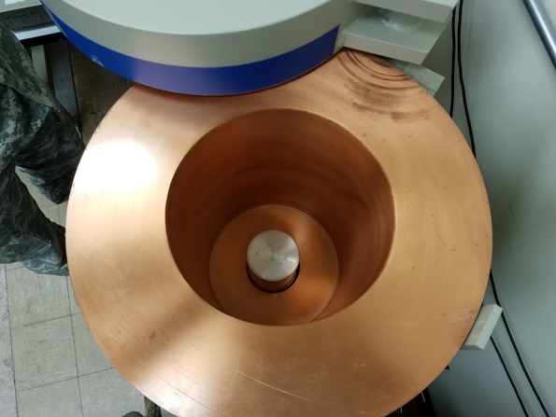

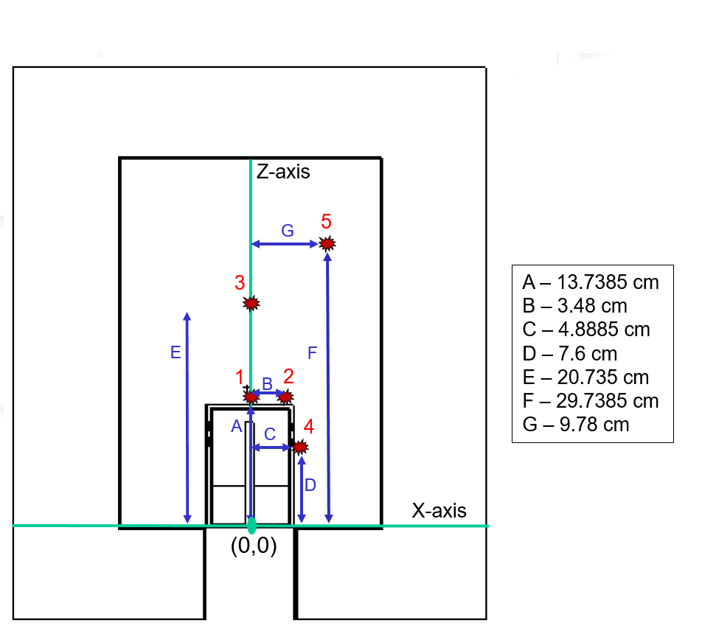

A plot of the spectra, and the calculated full-energy peak absolute efficiencies as a function energy was also provided by Lt Col O’day, which can be compared to the results of the simulated model.